PARK GUEST - ACCIDENT REPORT FORM
Last updated 10/2019

NAME OF PARK/TRAIL: ___________________________
(Attach trail and creative play area maps, if applicable.)
Please fill out both sides of this form completely and legibly.

Biking |  | Boating/Fishing |  | Camping |  | Creative Play Area
Golfing |  | Hiking/Walking |  | Horseback |  | Inline Skating
Picnicking |  | Swimming |  | Other (Specify)
Sliding |  | X-C Skiing |  | Other (Specify)

Is rental equipment involved? Y N Item: ID#: Receipt attached? Y N

IMPORTANT INFORMATION:

Date of Incident: Time of Incident: am/pm

Injured Person's Name: Age: DOB: Sex: M F

Name of Parent or Guardian, if Minor:

Home Address:
(City-State-Zip)
Home Phone: Work Phone:
Witness(es) of Accident:

Name: Age: DOB: Sex: ____

Address:
(City-State-Zip)
Home Phone: Work Phone:

TRANSPORTATION FROM ACCIDENT:

Drove self/other means:
(List method of transportation other than ambulance)

Ambulance to hospital:
(List name of Ambulance Service)

RESPONSIBILITY FOR COST OF AMBULANCE SERVICE (sign only if medical transportation is used):

I acknowledge that Three Rivers Park District is not responsible for the cost of medical transportation.

Signature: Date:
(of parent or guardian if under age 18)
DESCRIPTION OF INCIDENT OR ILLNESS (including injured person's description of accident)
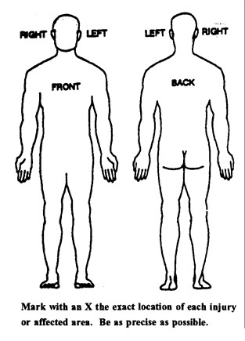
REFUSAL OF FIRST AID:

I hereby refuse any first aid treatment offered by Three Rivers Park District or volunteers.

Signature: Date:
(of parent or guardian if under age 18)

DESCRIPTION OF FIRST AID OR OTHER ACTION TAKEN:

REPORT PREPARED BY Staff Title

PARK GUEST ACCIDENT REPORT FORM INSTRUCTIONS:

Area/Park/Trail: Fill in park name, area in park where accident occurred, and attach trail or other area maps, if applicable. Check the activity in the following boxes.

Rental  Important | Yes or no answer; attach receipt, if rental.
Information  Transportation | Fill out this portion completely, including witnesses and all phone numbers.
from Accident  Responsibility for | Important. List name of ambulance service, if used.
Cost of Ambulance  Description of | Explain that Three Rivers Park District is not responsible for the cost of medical transportation; get signature to acknowledge this.
Accident or Illness | Your description of incident with as many details as you know. Use accompanying map to note area of injury. Also include injured person's description in their own words of have him/her complete.
Refusal of First Aid | Must be signed, if applicable.
First Aid Taken | Describe first aid and all action taken.
Report Prepared by | Your name and title (be sure you have included this).
Police / PSO | If called, include ranger's name; they will also fill out their own report.
Additional Remarks | Any additional information which you think might be helpful.

